PT 8604

MULTIPLE PARALLEL BB

The PT 8604 MULTIPLE PARALLEL BB can be installed in the PT 5210 VariTime™ Digital Sync generator and in the PT 5230 Digital Video Generator.

Packing list:
Check that the PT 8604 option package contains the following items:
 | Description: | Item | Quantity
 | Nut for BNC Connector | 2422 034 17419 | 6
 | Lockwasher for BNC Connector | 2422 034 17421 | 6
 | Pan Head Screw M3x6 | 2522 178 31058 | 8
 | COAX Cable | 4008 105 02690 | 1
 | Ribbon Cable with micro 20 pole connectors | 4008 105 04160 | 1
 | MULTIPLE PARALLEL BB | 4008 109 84490 | 1

The system is “plug and play” meaning that when the unit is mounted no configuration is needed in order to enable the PT 8604.

Installation procedure:
- Open the PT 5210/PT 5230 by removing the top cover.
- Remove the plastic blind from the back panel for the BNC connectors marked 6,5,10,9,4,3.
- Install the PT 8604 module.
- Mount the lockwasher and nut on the BNC connectors, do not tighten.
- Mount the 8 screws to fasten the PT 8604 generator module, do not tighten.
- Tighten the nut on the BNC connectors.
- Tighten the screws (and when used the hexagonal spacers).
- Mount the 8 screws into the spacers, do not tighten.
- Install the flat cable connecting the unit to the board in front of the module, a guide pin in each connector has to fit into a similar hole in the modules.
- Install the coax cable.
- Mount the top cover on the PT 5210/PT 5230.
- Place the new option type plate on the side of the generator in order to make later identification possible

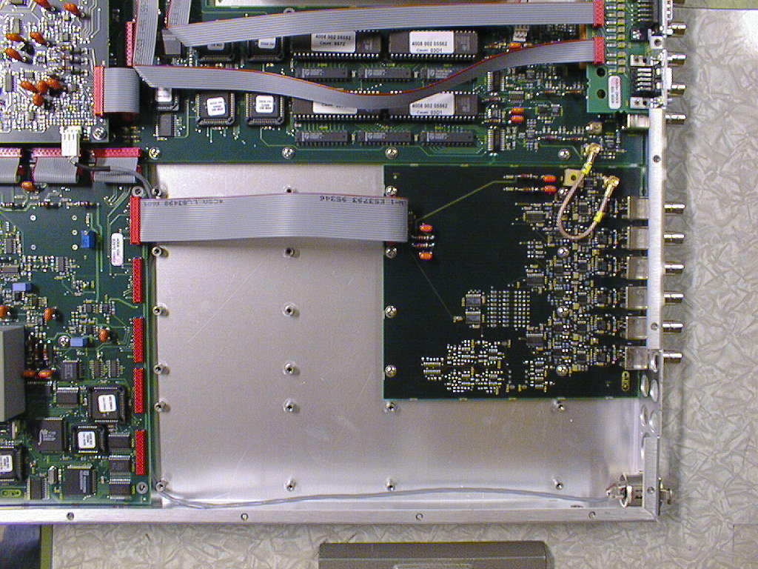
Picture 1.

Picture 1: The positioning of the PT 8604 MULTIPLE PARALLEL BB module in a PT5210/PT5230.

